CYBS 3323

Test 1

Fall 2024

|  |  |
| --- | --- |
| Name: | Daren Diaz |
| Student ID: | 113487126 |

**Instructions.** You have 120 minutes to complete this exam. You can access any resources of information, including calculators, electronic devices, textbooks, or notes. It would be recommended to solve the problems by yourself. In case of hand-writing, please write your answer clearly. If we cannot read your writing, it may be difficult to be graded.

**Academic Integrity Pledge.** This course operates under the rules of the Office of Academic Integrity at the University of Oklahoma. Your signature endorses the pledge below. After you finish your exam, please sign on the line below:

*I have neither given nor received aid on this examination, nor have I concealed any violations of the Academic Integrity.*

|  |
| --- |
|  |

1. Logical Operation in Discrete Mathematics:

Please answer the followings:

|  |  |
| --- | --- |
| (a). $1001∙1110$ =1111 | (b). $1010+0110$ =1000 |
| (c). $\overline{10100011+11001100}$ =01001000 | (d). $11110000⊕10101100$ =01011100 |

Where, $∙is AND, + is OR, \overline{} is NOT, ⊕ is XOR, and ⊙is XNOR.$

(e). Convert an octal number 256 into a binary number, show your works.

1. Octal digit 2: 2 in binary is 010
2. Octal digit 5: 5 in binary is 101
3. Octal digit 6: 6 in binary is 110

Now, we concatenate these binary values:

* 2 -> 010
* 5 -> 101
* 6 -> 110

So, the binary representation of the octal number 256 is **010101110**.

(f). Convert an octal number 33245717 into a hexadecimal number, show your works. **Step 1: Convert Octal to Binary**

Octal digits and their binary equivalents:

* 3 -> 011
* 3 -> 011
* 2 -> 010
* 4 -> 100
* 5 -> 101
* 7 -> 111
* 1 -> 001
* 7 -> 111

**Step 2: Group Binary into Hexadecimal**

Now, converting each 4-bit group to hexadecimal:

* 0011 -> 3
* 0110 -> 6
* 1101 -> D
* 1010 -> A
* 1110 -> E
* 0111 -> 7

**FINAL ANSWER: 36DAE7**

(20 Points)

2. General Computer Systems:

Please answer the followings:

(a). In the computer world, there are 3 levels,

Please explain each level with a figure.

+-------------------+

| Application |

| Software |

| (e.g., Browser, |

| Word Processor) |

+---------------------------------+

| Operating |

| System |

| (Windows, macOS, Linux) |

+----------------------------------+

| Hardware |

| (CPU, RAM, I/O) |

+-------------------+

(b). Write a Python script for reading a binary file, testData.bin, then print the first and second bytes only as a hex value.

# Script to read the first two bytes from a binary file and print them as hex

# Open the binary file in read mode

with open('testData.bin', 'rb') as file:

# Read the first two bytes

bytes_read = file.read(2)

# Check if we read 2 bytes

if len(bytes_read) == 2:

# Convert bytes to hex and format it

hex_values = bytes_read.hex()

print(f"First byte: {hex_values[0:2].upper()}") # First byte

print(f"Second byte: {hex_values[2:4].upper()}") # Second byte

else:

print("The file does not contain enough bytes.")

python read_bytes.py

(c). Please fill in the blanks.

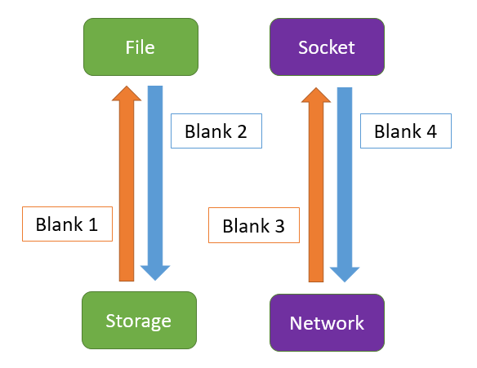

(12 Points)

3. Cybersecurity Job Interview Questions:

Please answer the followings:

(a). Explain the CIA triad in cybersecurity?

• Confidentiality: This principle ensures that sensitive information is accessed only by authorized individuals. It involves implementing measures such as encryption, access controls, and authentication to protect data from unauthorized access.

• Integrity: Integrity involves maintaining the accuracy and consistency of data over its lifecycle. This means protecting data from unauthorized modification or deletion. Techniques such as checksums, hashes, and access controls help ensure that data remains unaltered.

• Availability: Availability ensures that information and resources are accessible to authorized users when needed. This involves implementing measures to protect against disruptions, such as hardware failures, cyber-attacks, or natural disasters, through redundancy, backups, and disaster recovery plans.

(b). How do you define the differences between symmetric and asymmetric encryption?

(c). What is Layer-3 in the OSI models and its identifier?

(d). What is Internet (a.k.a. Public Network) in terms of the network devices compositions?

(12 Points)

4. Chip Architecture and Logic Gate:

Please answer the followings:

(a). What is the main difference between the Xilinx ZYNQ chipset and other Xilinx FPGA chipsets (ARTIX, KINTEX, VIRTEX) in terms of the SoC architecture?

In essence, the ZYNQ chipset's main differentiation is its combination of a processor and FPGA fabric in a single SoC architecture, enabling more complex and efficient designs compared to the standalone FPGA architectures of Artix, Kintex, and Virtex.

(b). What is the difference between FPGA and ASIC?

In summary, FPGAs provide flexibility and quick development, while ASICs offer optimized performance and efficiency for specific applications at scale. The choice between them depends on the project requirements, volume, and desired flexibility.

(c). Using the logic gate, draw the basic adding circuit with one XOR gate and one AND gate.

A ----| |

| XOR |---- S (Sum)

B ----| |

A ----| |

| AND |---- C (Carry)

B ----| |

(12 Points)

5. Simple Codes/Scripts:

Please answer the followings:

|  |  |
| --- | --- |
| (a). In bash, what is the result?  #!/bin/bash  name=OUPI;  echo ‘Hello, $name student!’;  Hello, $name student! | (b). In Python, what is the result?  print(ord(‘a’) == 116)  will result in False |
| (c). In python, what is the result?    print(1.1 + 0.3 == 1.4)  This occurs due to floating-point precision issues. When you perform the addition 1.1 + 0.3, the result is not exactly 1.4 but rather a value very close to it, which leads to the comparison returning False. | (d). In python, what is result?  cars = ["Ford", "Fiat", "KIA"]  print(cars[3])  will result in an Index Error. |

(16 Points)

6. Cryptography:

Please answer the followings:

(a). Use exhaustive key Search to decrypt the following cipher text, which was encrypted using a Shift cipher, and to find the key. (number of the shift)

'**QKKVEUAXLXOKTJYIRUYKHAZEUAXKTKSOKYIRUYKX**'

'KEEPYOURFRIENDSCLOSEBUTYOURENEMIESCLOSER'

(b). Use Vigenere cipher to decrypt the message ' **FVIWFBSBMFDG**' using the keyword ‘**JOKER**’

WHYSOSERIOUS

(c) Recall the Project #0: With a 12-bit key **ABF** ( 101010111111 ), encrypt an 8-bit block data as ASCII code ‘**e**’ = 101 ( 01100101 ) by using the Scaled-Down Data Encryption Standard (SD-DES) system, show your works.

(28 Points)